Chapter 17, Problem 49.

- For the periodic waveform in Prob. 17.5, find the rms value.
- Use the first five harmonic terms of the Fourier series in Prob. 17.5 to determine the effective value of the signal.
- Calculate the percentage error in the estimated rms value of z(t) if

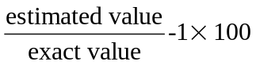

Chapter 17, Problem 5

Obtain the Fourier series expansion for the waveform shown in Fig. 17.49.

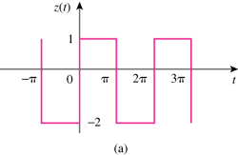
2
-4

Figure 17.49
For Probs. 17.5 and 17.49.

